


University of Baltistan Skardu

Public College, Skardu
Department of Computer Science

“File Encryption/Decryption
Program using XOR Cipher”
Computer Organization and Assembly Language
By:
Mr. SOHAIL-2024-uobsac-1362
Mr. WILAYAT ALI-2024-uobsac-1407
Mr. WAQAR AHMED-2024-uobsac-1367
Mr. SHABBIR HUSSAIN-2024-uobsac-1361
Submitted to: Mr. Sajid Ali

Table of content:
1. Introduction 1
2. Objectives 2
3. Tools Used 2
4. Concept of XOR Clipher 3
5. Working Mechanism 5
6. Assrmbly Code Explanation 6
7. Program Outputs 6
8. Applications 6
9. Importance 7
10. Limitations 7
11. Future Work 8
12. Conclusion 8

1. Introduction
In today’s digital world, data security is one of the most critical concerns. Whether it’s personal information, confidential documents, or financial records, protecting digital files from unauthorized access is essential. File encryption and decryption play a vital role in securing data by converting readable data (plaintext) into unreadable form (ciphertext) and vice versa using specific algorithms and keys. This ensures that even if the data is intercepted, it cannot be understood without the correct decryption key.
Encryption is the process of encoding the data so that only authorized users can access it. One of the simplest encryption techniques is the XOR cipher, where each byte of the file is XORed with a key. This method, while basic, helps in understanding the foundation of more complex encryption mechanisms. Decryption, on the other hand, is the process of converting the encrypted data back to its original form using the same key and algorithm.
Implementing file encryption/decryption in a programming project enhances understanding of cryptographic principles, binary file handling, and user interaction through file input/output. In this project, we use a key provided by the user to encrypt or decrypt a given file. The same key must be used for both processes to maintain data integrity.
Overall, this type of project is not only practical for real-world applications but also an excellent learning tool for understanding how basic security systems work. It strengthens core programming skills while also introducing concepts from cybersecurity and data protection.

2. Objective
The primary objective of the file encryption/decryption project is to develop a simple yet effective system that secures digital data by converting it into an unreadable format and restoring it when required. With the increasing reliance on digital communication and file sharing, sensitive data is often at risk of being accessed by unauthorized individuals. This project aims to address this issue by providing a mechanism to protect files using encryption algorithms and retrieve them securely through decryption.
One of the key goals is to help students and developers understand the fundamentals of cryptography, particularly symmetric key encryption. By using a basic XOR cipher algorithm, the project introduces how a key can be used to transform data in such a way that only someone with the same key can reverse the process. This provides a foundational understanding of how modern encryption techniques like AES or DES work, making the XOR cipher a great starting point for learning.

3. Tools Used
In the development of the file encryption and decryption project, various software tools and programming concepts are used to build a functional and user-interactive system. One of the main tools is the Python programming language, known for its simplicity and powerful built-in libraries. Python provides easy-to-use modules for handling files, performing bitwise operations like XOR, and managing user input/output, making it ideal for implementing the core logic of encryption and decryption.
A critical aspect of this project involves file handling, for which Python’s built-in functions like open(), read(), and write() are used.
These tools enable the program to read the contents of a file in binary mode, process each byte, and then write the transformed data to a new file. This process is essential to ensure that the encryption affects every part of the file accurately, whether it's a text file, image, or document.

4. Concept of XOR Cipher
The XOR cipher is one of the simplest and most commonly used techniques in symmetric encryption, especially for educational and lightweight applications. XOR stands for “exclusive OR,” a logical operation that outputs true (1) only when the inputs differ. In the context of file encryption, this operation is performed at the binary level on each byte of the file using a key. The beauty of XOR is in its reversibility—applying the same key twice will bring the original value back, which makes it ideal for both encryption and decryption using the same logic.
In the file encryption process, the content of the file is read byte by byte, and each byte is XORed with a corresponding byte from the key (which can be repeated or looped if shorter than the file). This transforms the data into an unreadable format, known as ciphertext. When decrypting, the same operation is applied again using the same key, and the original file content is restored. This is because of the property: (A XOR B) XOR B = A.
The XOR cipher does not require complex mathematical computations, which makes it fast and lightweight, perfect for small files or systems with limited resources. However, its simplicity is also a limitation—it is not secure against advanced attacks, especially if a weak or repeating key is used. That said, it still serves as an excellent starting point for students to understand how bitwise operations can be used to secure data.
In the file encryption/decryption project, using the XOR cipher allows developers to explore practical applications of low-level operations like bit manipulation and binary file processing. It demonstrates how even simple logic can be used to achieve data confidentiality, while also laying the foundation for understanding more secure encryption methods used in real-world systems.

5. Working Mechanism
1. Input file is selected.
2. User provides an encryption key (a byte or character).
3. Program reads each byte of the file.
4. XOR operation is performed on each byte with the key.
5. The encrypted file is saved.
6. Running the same process again with the same key decrypts the file.
┌────────────────────────┐
│ Start Program │
└────────────┬───────────┘
↓
┌────────────────────────┐
│ Open input file │
└────────────┬───────────┘
↓
┌────────────────────────┐
│ Read a byte from file │
└────────────┬───────────┘
↓
┌────────────────────────┐
│ XOR byte with key │
└────────────┬───────────┘
↓
┌────────────────────────┐
│ Write encrypted byte │
└────────────┬───────────┘
↓
┌────────────────────────┐
│ End of file? │
└───────┬────────┬───────┘
│ Yes │No |
↓
┌────────────────────────┐
│ Close file │
└────────────┬───────────┘
↓
┌────────────────────────┐
│ Stop │
└────────────────────────┘

6. Assembly Code Explanation
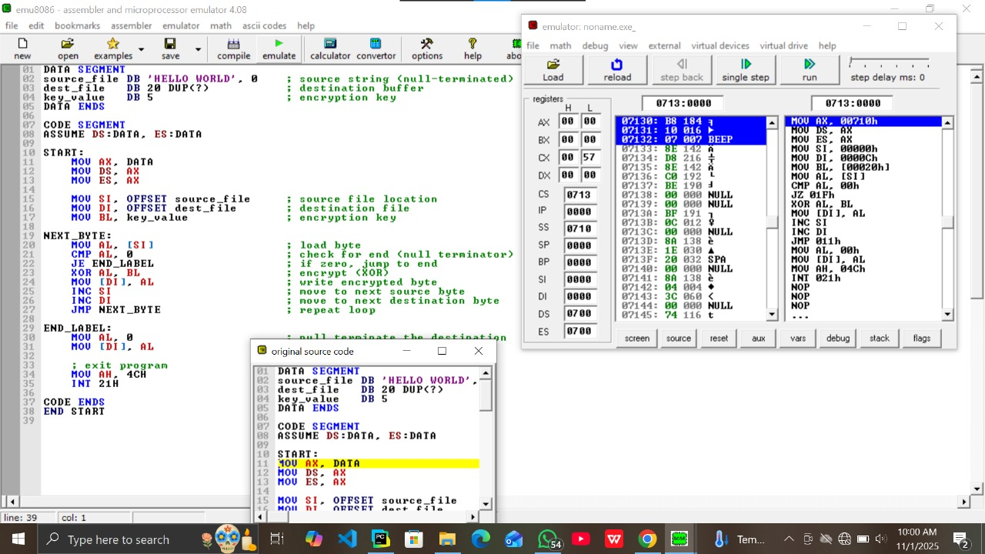

7. Program Output

8. Applications
File encryption and decryption are widely used in various fields to ensure secure handling of sensitive data. One of the most common applications is in personal data protection. Users often store personal information such as ID documents, medical records, financial statements, or passwords on their devices. Encrypting these files prevents unauthorized access in case the device is lost, stolen, or hacked. Decryption allows the rightful user to retrieve the data when needed, maintaining privacy and security.
Another key application is in corporate and business environments. Companies regularly handle confidential files such as contracts, employee records, project plans, or client data. Encryption ensures that only authorized staff or departments can access specific files, helping prevent data leaks, industrial espionage, or misuse of sensitive information. Many businesses also use encrypted backups to secure critical files from ransomware attacks or system failures.

9. Importance
File encryption and decryption play a vital role in ensuring data security and privacy in both personal and professional digital environments. As data becomes one of the most valuable assets in the modern world, protecting it from unauthorized access, theft, or tampering has become essential. Encryption transforms readable data into an unreadable format, and decryption restores it back to its original form, ensuring that only trusted users can access sensitive information. One of the major reasons for the importance of encryption is protection against cyber threats. With the rise of hacking, identity theft, and ransomware attacks, encrypted files provide a strong defense. Even if attackers gain access to files, the encrypted content is useless without the correct key. This safeguards not only personal privacy but also critical information for organizations, governments, and institutions.

10. Limitations
File encryption and decryption, while essential for data security, and come with several limitations that affect their effectiveness and usability .One major limitation is the dependence on key security. If the encryption key is lost, forgotten, or stolen, the encrypted data becomes inaccessible or vulnerable. Without proper key management, even the strongest encryption algorithms cannot protect the data, as unauthorized users with access to the key can easily decrypt the files.
Another limitation is the performance overhead introduced by encryption and decryption processes. Encrypting large files or multiple files can consume significant processing power and time, especially on devices with limited resources like smartphones or older computers. This can slow down workflows, particularly when encryption is applied repeatedly or in real-time scenarios, such as streaming or cloud storage synchronization.
The simplicity of some encryption algorithms, such as the XOR cipher, introduces security vulnerabilities. XOR encryption, for example, is susceptible to cryptanalysis if the key is reused or too short. More advanced encryption methods require complex algorithms and longer keys, which can be difficult to implement correctly without expert knowledge, leading to possible implementation errors and weak encryption .Finally, file encryption does not protect against all types of threats. It safeguards data confidentiality but may not prevent data corruption, deletion, or unauthorized access through other means such as malware or insider threats. Encryption also does not guarantee data integrity or authenticity unless combined with additional security measures like digital signatures or hashing. Therefore, file encryption should be part of a broader security strategy rather than the sole protective measure.

11. Future Work
As digital threats continue to evolve, the future of file encryption and decryption lies in developing more advanced, adaptive, and intelligent encryption techniques. One key area for future work is the integration of artificial intelligence (AI) to detect potential security threats and automatically strengthen encryption strategies. AI could help identify unusual access patterns, recommend stronger keys, or adapt the encryption method based on the sensitivity of the data, providing a dynamic layer of security.
Another promising direction is the implementation of quantum-resistant encryption algorithms. With the rise of quantum computing, traditional encryption methods like RSA and even advanced symmetric key algorithms could become vulnerable. Researchers are now working on post-quantum cryptography techniques that will remain secure even against the processing power of quantum machines. Future file encryption systems will likely adopt these techniques to prepare for next-generation computing threats.

12. Conclusion
File encryption and decryption are fundamental processes in safeguarding digital information against unauthorized access and cyber threats. By converting readable data into an encrypted format using specific keys, encryption ensures that sensitive files remain confidential and secure during storage or transmission. Decryption reverses this process, restoring the original data only to those possessing the correct key. This balance between accessibility and security is vital in today’s digital age where data breaches and hacking incidents are increasingly common.
Despite its importance, file encryption comes with challenges, including key management, performance impacts, and vulnerabilities in simpler algorithms. However, advancements in cryptographic techniques and computing power continue to enhance the strength and efficiency of encryption methods. Modern encryption algorithms, when correctly implemented, provide robust protection suitable for personal use, business operations, and government applications alike.

Reference:
Lv, H., Wang, X., Zhang, Y., Huang, C., Dou, S., Ye, J., Gui, T., Zhang, Q. and Huang, X., 2024. Codechameleon: Personalized encryption framework for jailbreaking large language models. arXiv preprint arXiv:2402.16717.
Available at: https://doi.org/10.48550/arXiv.2402.16717
Ashrif, F. F., Sundararajan, E. A., Hasan, M. K., Ahmad, R., Hashim, A. H. A., & Talib, A. A. (2024). Provably secured and lightweight authenticated encryption protocol in machine-to-machine communication in industry 4.0. Computer Communications, 218, 263-275.
Available at: https://doi.org/10.1016/j.comcom.2024.02.008
Mohseni, S., Mohammadi, S., Tilwani, D., Saxena, Y., Ndawula, G. K., Vema, S., ... & Gaur, M. (2025, April). Can LLMs Obfuscate Code? A Systematic Analysis of Large Language Models into Assembly Code Obfuscation. In Proceedings of the AAAI Conference on Artificial Intelligence (Vol. 39, No. 23, pp. 24893-24901).
Available at: https://doi.org/10.1609/aaai.v39i23.34672
Yang, J., 2022. Computer data encryption system based on nonlinear partial differential equations. Mobile Information Systems, 2022(1), p.3395019.
Available at: https://doi.org/10.1155/2022/3395019

